Biometric data credential
# Source: AI Source: Provided by: [Data Path: Persons Table -> ID Column: 1, Name_En Column: Motasem Essam] -> From: [ChatGPT] on [1/18/2026]
A Biometric data credential is a type of authentication that uses unique physical or behavioral traits of a person to verify their identity. Unlike passwords or tokens, it relies on something you are.

👤 What is Biometric Data?
# Source: AI Source: Provided by: [Data Path: Persons Table -> ID Column: 1, Name_En Column: Motasem Essam] -> From: [ChatGPT] on [1/18/2026]
Biometrics are measurable, unique characteristics of a person, such as:
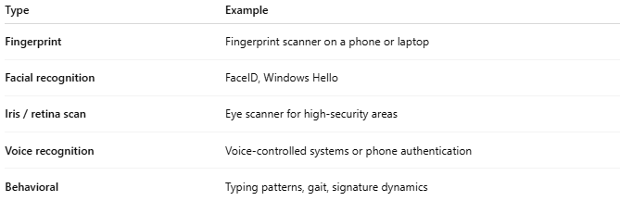
Type | Example
Fingerprint | Fingerprint scanner on a phone or laptop
Facial recognition | FaceID, Windows Hello
Iris / retina scan | Eye scanner for high-security areas
Voice recognition | Voice-controlled systems or phone authentication
Behavioral | Typing patterns, gait, signature dynamics

🛠️ How it works
# Source: AI Source: Provided by: [Data Path: Persons Table -> ID Column: 1, Name_En Column: Motasem Essam] -> From: [ChatGPT] on [1/18/2026]
- Enrollment: The user’s biometric data is captured and stored (often as a template, not raw data).
- Authentication: When logging in, the system compares the new biometric scan to the stored template.
- Decision: If it matches within an acceptable threshold → access granted; if not → access denied.
Modern systems usually store hashed or encrypted biometric templates for security.

📍 Where it’s used
# Source: AI Source: Provided by: [Data Path: Persons Table -> ID Column: 1, Name_En Column: Motasem Essam] -> From: [ChatGPT] on [1/18/2026]
- Smartphones and tablets (unlocking devices)
- Laptops (Windows Hello, Touch ID)
- Security systems (doors, vaults)
- Banking and payment apps
- Airports & border control (passports, automated gates)

✅ Advantages
# Source: AI Source: Provided by: [Data Path: Persons Table -> ID Column: 1, Name_En Column: Motasem Essam] -> From: [ChatGPT] on [1/18/2026]
- Hard to forge or share
- Convenient and fast (no passwords to remember)
- Difficult to brute-force
- Can enhance security with multi-factor authentication

⚠️ Disadvantages
# Source: AI Source: Provided by: [Data Path: Persons Table -> ID Column: 1, Name_En Column: Motasem Essam] -> From: [ChatGPT] on [1/18/2026]
- Biometric data cannot be changed if leaked
- False positives / false negatives possible
- Expensive hardware required for some types
- Privacy concerns with storing sensitive biometric data

🔒 Best practices
# Source: AI Source: Provided by: [Data Path: Persons Table -> ID Column: 1, Name_En Column: Motasem Essam] -> From: [ChatGPT] on [1/18/2026]
- Store only encrypted biometric templates, not raw images
- Use biometrics with additional factors (MFA) for sensitive systems
- Secure communication channels (HTTPS / TLS)
- Limit access to biometric databases

🧠 Authentication factor
# Source: AI Source: Provided by: [Data Path: Persons Table -> ID Column: 1, Name_En Column: Motasem Essam] -> From: [ChatGPT] on [1/18/2026]
- Something you are

